**S, Ago 24** - **OPERACIONES CON FRACCIONARIOS**

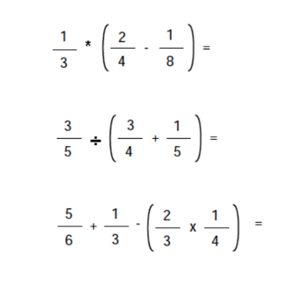

A

B

C

**A**

Inicial: 1/ 3 * (2/4 - 1/ 8)

2/4 - 1/ 8 = (2 * 8 - 4*1 ) / 4*8 = ( 16 - 4 ) / 32 = 12 / 32 = 6/16 = **3/ 8**

1/ 3 * **3/ 8** = 3/24 = **1/8**

**B**

Inicial : (3/5 ) / (3/4 + 1/5)

(3/4 + 1/5) = 3*5 + 4* 1 / 4* 5 = 15+4/20 = 19/20

(3/5) / ( 19/20 ) = (3/5) * (20/19) = 60/ 95 = **12/19**

**C**

Inicial: (5/6 + 1/3 ) - (2/3 * 1/4 )

5/6 + 1/3 = (5 * 3 + 6 * 1 )/ 6 * 3 = 15+6 / 18 = 21 / 18 = 7/ 6

2/3 * 1/4 = 2/12

7/ 6 - 2/12 = (7 * 12 - 6* 2 ) / 6 * 12 = 84 - 12 / 72 = 72/72 = **18/18 = 1**